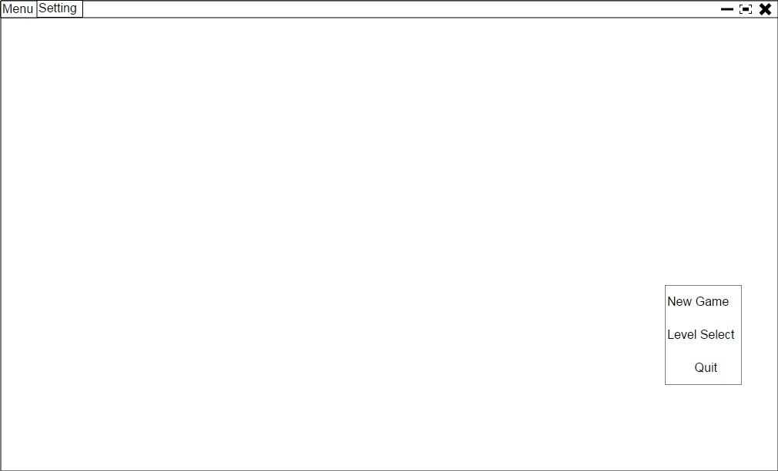

Level select screen

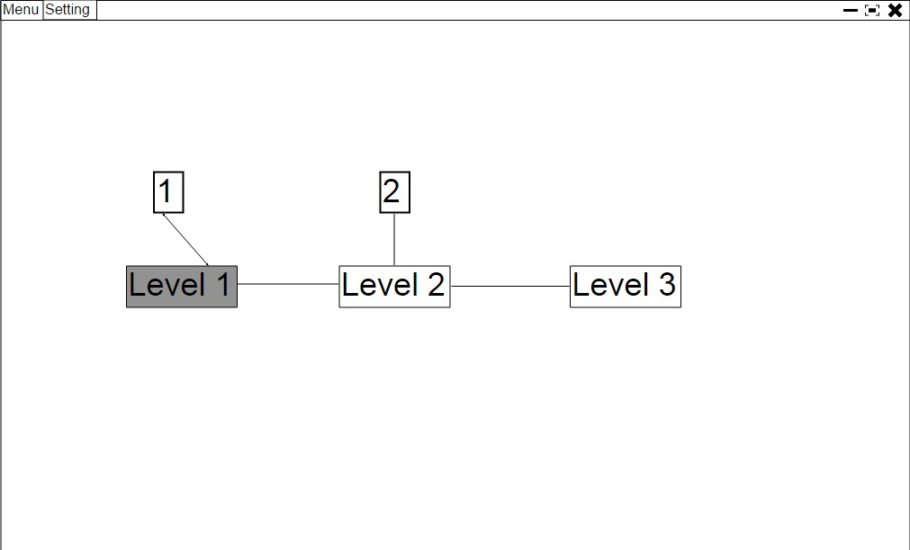

1. With the grey color game that mean, this level already been unlocked. The player can start from this level directly.

2. With the white base color that mean this level had not unlocked yet. The player must start at last unlock and pass game to unlock it.

Level 1

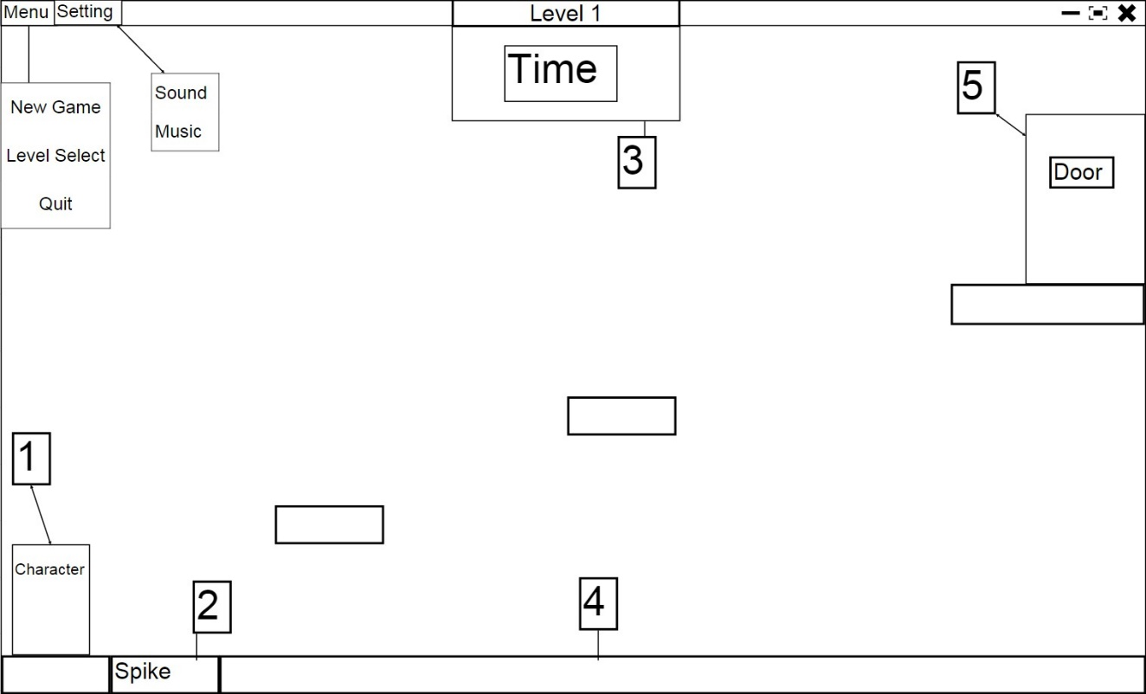

1. Character initial position when the game starts. When character dead, Character will resume at this position

2. Basic Hazard in the game, always lethal. Character will dead if tough it.

3. Block would be a safe ground if there were not mention.

4. Time will calculate how long player will be spent on this level.

5. Door use to transfer and unlock to next level

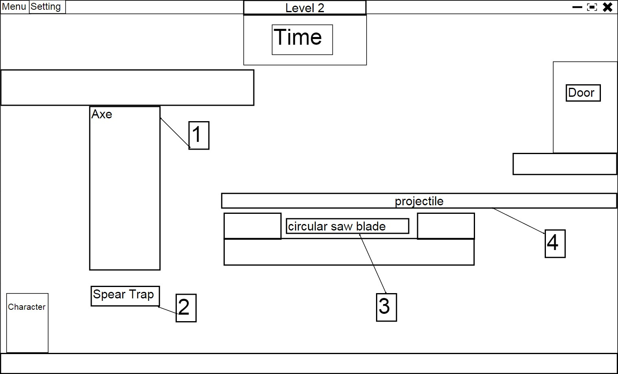

1. Axe will keep swing, its only damager if character touch it.

2. Spear Trap- Spear will pop out after player stand there for a will then it because lethal trap, will take spear back to unlethal state after a while.

3. Circular saw blade, keep moving backward will return its direction after touch something, only lethal when touching it.

4. The projectile trap will shot out one single spear, again only danger when you touch it.

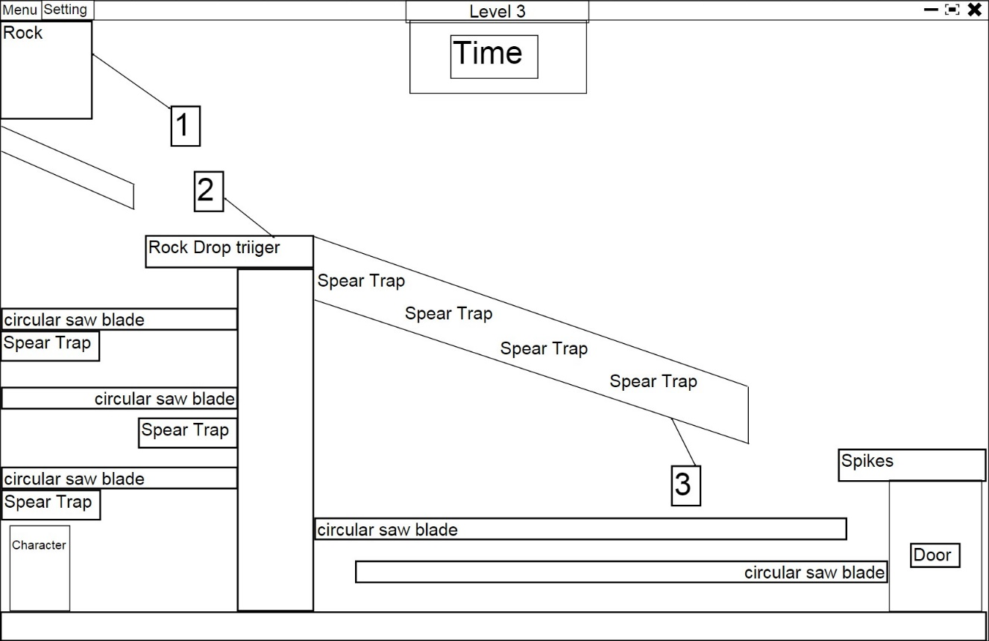

1. Rock will drop down, and keep rolling it will be lethal when character touches it.

2. Trigger, use to release rock trap.

3. This is an ice road, and character only can accelerate and decelerate on it.